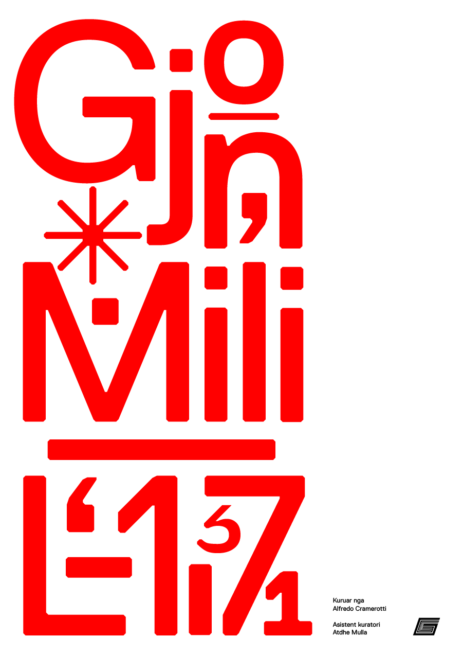
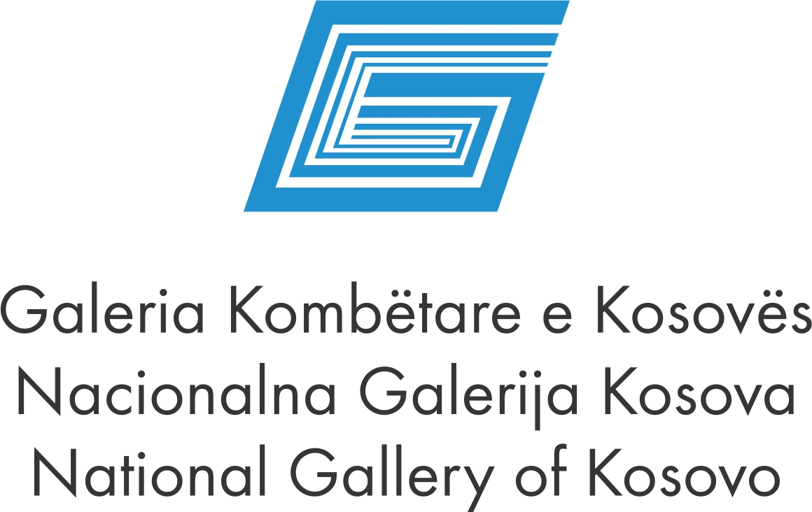

NATIONAL GALLERY OF KOSOVA
Announces an open call
For participation in the 15th edition of the International Photography
exhibition-award

“Gjon Mili" 2017
Curated by Alfredo Cramerotti
Assistant curator: Atdhe Mulla
Artistic Liaison: Alexis Brocchi

HYPERIMAGING! IMAGES IN AND OUT OUR SCREENS

Rationale

We refer to images, or the act of creating images, to act socially, politically and even privately. As a consequence of the digital age of photography, the way we are involved in image making is continuous:we can confer it a specific professional or artistic function, or embed it in they way we shape our existence.

When digital images areimposing themselves as a visual translation of the self, the understanding of photography is striving to go away from standard representational practices. Images compose a visual timeline, comparable to a textual linear narrative, where the grammar is made of our shopping lists, chats, social media’s comments or work emails.

Although these images are not coherent when considered together and are produced for different reasons, they become knowledge ‘chunks’ thatvisually translate different contexts into what we wish others to think of us. They can thereforebe understood as a pictorial alphabet, where the possibilities of communicating are infinite and universal, freed from constraints related to textual translation. The result is a flow of visual forms and meanings that are interchangeable, independently from the situations in which they were generated and consumed.
The 2017 “Gjon Mili” Biennial & Award wants to query this hypothesis; focusing on image-making in the digital era, it wants to test if ‘visual authorship’ today is still associated with holding a specific position through the idea of representation, or rather is about delving into an ever-changing process that never produces a ‘finished’ work to display.

Beyond a classic photographic exhibition, the 2017 “Gjon Mili” Biennial & Award will therefore exhibit an expanded narrative of photography through photo-objects, installations, projections, visual data streams and ‘moving wallpapers’ that will put the curatorial rationale to test, and will engage the audience on a path to discovery, self-reflection and open enquiry about the status of visual culture in the beginning of the 21st century. -Alfredo Cramerotti
Application documents:
- Image and /or concept that reflect the curatorial concept
- Application form ( available at the NGK or by emailingrequest at info@galeriakombetare.com), portfolio and biography.
- . The most successful work will reveive “Gjon Mili “award in value of 1000 euros.
Note:
- Finished works are not accepted for the application;
- The works submitted must not be exhibited in the past in NGK;
- Applications to be addressed in aclosed envelope to:
“Galeria Kombëtare e Kosovës, Rr. Agim Ramadani 360, 10000, Prishtina, Republic of Kosovo” received before end of working hours on 20.07.2017
- For more information contact Lirije Buliqi at +38138 225 627

